# **Mastering PostgreSQL Configuration: A Deep Dive into**postgresql.conf

PostgreSQL is one of the most powerful open-source databases in the world, but much of its true potential lies hidden in its configuration files. At the heart of PostgreSQL’s server configuration sits a single, incredibly important file: postgresql.conf.

In this post, we’ll break down everything you need to know about postgresql.conf, from its purpose to hands-on examples for modifying it — including full setup scripts to configure your PostgreSQL environment like a pro.

## **🔧 What is**postgresql.conf**? — The Heart of PostgreSQL Configuration**

If you’re working with PostgreSQL, you’ll eventually meet one of the most important files behind the scenes:  
****postgresql.conf**** — the master configuration file that controls how PostgreSQL behaves.

Let’s break it down in simple but powerful terms 👇

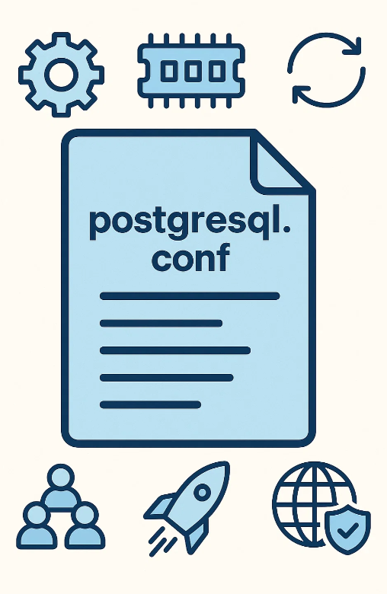

## **📂 Why is**postgresql.conf**so important?**

Every time your PostgreSQL server starts up, it reads the settings from this file to decide:

* 🔄 How much memory to use
* ⚙ How many connections to allow
* 🔐 Which features to enable or disable
* 🚀 How to optimize for performance
* 📊 How much logging to produce
* 🌐 How to handle networking and authentication

In other words:  
👉 *postgresql.conf is PostgreSQL’s brain — it tells the server what to do.*

## **📍 Where to Find**postgresql.conf**in PostgreSQL**

When you start tuning or troubleshooting your PostgreSQL server, one of the first tasks is to locate the postgresql.conf file — the primary configuration file controlling how PostgreSQL behaves.

Unlike some database systems that always store config files in the same place, PostgreSQL’s location for postgresql.conf can vary depending on:

* 🔧 Your operating system (Linux, Windows, Mac)
* 📦 How PostgreSQL was installed (package manager, source build, containerized, managed cloud service)
* 🎯 Custom configuration choices during installation

## **🔎 Typical Default Location on Linux**

If PostgreSQL was installed using standard package managers like apt (Ubuntu/Debian) or yum/dnf (RHEL/CentOS), the postgresql.conf file is often located at:

/etc/postgresql/{version}/main/postgresql.conf

For example, on a PostgreSQL 16 installation, the full path might look like:

/etc/postgresql/17/main/postgresql.conf

## **🔎 Typical Default Location (Alternative Builds)**

* On RPM-based distros (RHEL, CentOS, Rocky, AlmaLinux):

/var/lib/pgsql/{version}/data/postgresql.conf

* On Windows (default PostgreSQL installer):

C:\Program Files\PostgreSQL\{version}\data\postgresql.conf

* Inside Docker or container environments:

/var/lib/postgresql/data/postgresql.conf

## **🔎 How to Locate**postgresql.conf**Programmatically**

Since location can vary, here are two reliable ways to find it no matter your environment:

## **✅ Method 1 — Using SQL (Always Works)**

PostgreSQL itself knows where its configuration file is loaded from. You can ask it directly:

SHOW config_file;

****Example Output:****

/var/lib/pgsql/17/data/postgresql.conf

🔥 **Pro Tip:** This is the most reliable method and works even inside remote or cloud-hosted PostgreSQL instances.

## **✅ Method 2 — Using OS Shell Commands**

You can search for the file directly at the OS level:

sudo find / -name postgre\*.conf

This searches your entire filesystem for any file starting with postgre and ending with .conf.

****Example Output:****

/etc/postgresql/17/main/postgresql.conf  
/var/lib/postgresql/17/main/postgresql.auto.conf

* ✅ postgresql.conf: Main configuration file
* ✅ postgresql.auto.conf: Automatically generated file for runtime configuration changes via ALTER SYSTEM

## **⚠ Why Knowing the Location is Important**

* 🔧 To modify PostgreSQL behavior (memory, performance, replication, security)
* 🔒 To review security and access settings
* 🚀 To enable advanced features like pg_stat_statements, WAL archiving, or connection pooling
* 🐛 To troubleshoot performance issues

Press enter or click to view image in full size

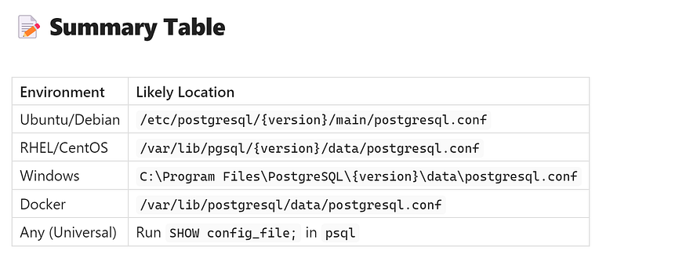

🧠 **Remember:** Always make a backup before editing postgresql.conf and reload/restart PostgreSQL to apply changes.

## **⚙️ Key Parameters in**postgresql.conf**: A Quick Guide for PostgreSQL Performance Tuning**

The postgresql.conf file is the heart of PostgreSQL's configuration. With hundreds of tunable parameters, knowing which ones truly matter can save you hours of troubleshooting and greatly improve your database performance, reliability, and security.

Let’s break down the most important settings — grouped into categories — so you know exactly what each one controls.

## **🔗 Connection Settings — Control How Clients Connect**

## **1️⃣**max_connections

* ****What it does:****  
  Defines the maximum number of concurrent client connections allowed.
* ****Why it matters:****  
  Setting this too high can exhaust server memory; too low may reject client requests.
* ****Example:****

max_connections = 200

## **2️⃣**statement_timeout

* ****What it does:****  
  Terminates any SQL statement that runs longer than the specified time.
* ****Why it matters:****  
  Prevents runaway queries from locking up resources.
* ****Example:****

statement_timeout = 60000 # 60 seconds

## **3️⃣**ssl

* ****What it does:****  
  Enables or disables SSL encryption for client connections.
* ****Why it matters:****  
  Secures connections between clients and the database server.
* ****Example:****

ssl = on

## **🖥 Resource Management — Control Memory & I/O Efficiency**

## **4️⃣**shared_buffers

* ****What it does:****  
  Allocates memory for PostgreSQL’s internal cache of frequently accessed data.
* ****Why it matters:****  
  One of the most impactful parameters for read performance.
* ****Rule of thumb:**** 15%–25% of total RAM.
* ****Example:****

shared_buffers = 4GB

## **5️⃣**work_mem

* ****What it does:****  
  Amount of memory used for complex operations like sorts and joins *per query*.
* ****Why it matters:****  
  Affects performance for analytical queries.
* ****Example:****

shared_buffers = 4GB

## **6️⃣**effective_io_concurrency

* ****What it does:****  
  Tells PostgreSQL how many I/O operations can be performed in parallel.
* ****Why it matters:****  
  Crucial for systems with SSDs or fast disks.
* ****Example:****

effective_io_concurrency = 200

## **🚀 Query Performance — Optimize How Queries Are Executed**

## **7️⃣**enable_seqscan

* ****What it does:****  
  Allows or disallows sequential scans.
* ****Why it matters:****  
  Sometimes disabling can help test index usage; generally best left enabled.
* ****Example:****

enable_seqscan = on

## **8️⃣**autovacuum

* ****What it does:****  
  Controls automatic cleanup of dead rows to prevent bloat.
* ****Why it matters:****  
  Essential for healthy long-term performance.
* ****Example:****

autovacuum = on

## **9️⃣**track_counts

* ****What it does:****  
  Enables statistics collection for queries.
* ****Why it matters:****  
  Required for performance monitoring tools like pg_stat_statements and autovacuum effectiveness.
* ****Example:****

track_counts = on

## **📄 Logging & Monitoring — Control What PostgreSQL Logs**

## **🔟**log_destination

* ****What it does:****  
  Sets where logs are written (e.g., stderr, csvlog, syslog).
* ****Why it matters:****  
  Directs logs to the right place for analysis.
* ****Example:****

log_destination = 'stderr'

## **1️⃣1️⃣**log_statement

* ****What it does:****  
  Controls which SQL statements are logged.
* ****Options:**** none, ddl, mod, all.
* ****Example:****

log_statement = 'mod'

## **1️⃣2️⃣**log_min_messages

* ****What it does:****  
  Minimum severity level for messages to be logged.
* ****Options:**** DEBUG, INFO, NOTICE, WARNING, ERROR, FATAL, PANIC.
* ****Example:****

log_min_messages = 'WARNING'

## **🔄 Replication Settings — Critical for High Availability & Disaster Recovery**

## **1️⃣3️⃣**wal_level

* ****What it does:****  
  Sets how much information is written to the Write-Ahead Log.
* ****Options:**** minimal, replica, logical.
* ****Why it matters:****  
  Required for streaming replication and logical replication.
* ****Example:****

wal_level = replica

## **1️⃣4️⃣**synchronous_commit

* ****What it does:****  
  Controls whether transactions wait for WAL writes to complete.
* ****Why it matters:****  
  Can improve performance but may trade off durability.
* ****Example:****

synchronous_commit = on

## **1️⃣5️⃣**max_wal_senders

* ****What it does:****  
  Maximum number of concurrent WAL sender processes for replication.
* ****Why it matters:****  
  Controls how many replicas you can maintain.
* ****Example:****

max_wal_senders = 10

## **🚀 Pro Tip**

After changing postgresql.conf, always remember to reload or restart PostgreSQL for changes to take effect:

sudo systemctl reload postgresql

## **🧠 Why These Parameters Matter**

* 🔧 Tuning these settings can dramatically improve query speed and resource usage.
* 🔒 Help you secure connections and control user access.
* 📊 Allow better monitoring, logging, and troubleshooting.
* 🔄 Enable replication for high availability systems.

By mastering just these key parameters, you’ll already be ahead of 80% of PostgreSQL admins — and your database will thank you for it.

## **✏️ How to Modify**postgresql.conf**in PostgreSQL**

In PostgreSQL, the postgresql.conf file is the central configuration file that controls how your PostgreSQL server behaves. It includes critical parameters that affect performance, connections, security, logging, and more. Whenever you need to fine-tune PostgreSQL, you usually modify this file.

Let’s walk through exactly ****how to modify postgresql.conf safely****.

## **🔧 Step 1 — Edit the**postgresql.conf**File**

The first step is to locate and open the file for editing. Depending on your PostgreSQL version and installation method, the file path may vary. For PostgreSQL 16 installed on a typical Linux system, it’s often located here:

sudo vi /etc/postgresql/16/main/postgresql.conf

✅ If you’re not comfortable with vi, you can also use nano:

sudo nano /etc/postgresql/16/main/postgresql.conf

## **🔄 Example Configuration Change**

Suppose you want PostgreSQL to accept connections from any IP address (which is often required for remote access). You would change the following setting inside postgresql.conf:

listen_addresses = '*'

* By default, listen_addresses may be set to localhost, which only allows local connections.
* Changing it to '*' allows connections from any IP address (assuming you also properly configure pg_hba.conf).

⚠️ **Security Note:** Allowing all IPs requires additional network and firewall security. Only open PostgreSQL to trusted networks.

## **📦 Step 2 — Backup the Configuration File (Best Practice)**

Before making any changes to PostgreSQL configuration files, ****always create a backup****. This ensures you can easily restore the previous working configuration if something goes wrong.

Run:

cp /etc/postgresql/16/main/postgresql.conf /etc/postgresql/16/main/postgresql.conf_$(date +%Y%m%d)

* This command creates a backup copy of the config file with today’s date attached (using date +%Y%m%d), making it easy to identify when the backup was made.

## **🔄 Step 3 — Apply Changes by Restarting PostgreSQL**

After modifying postgresql.conf, you need to restart PostgreSQL to apply the new configuration:

sudo systemctl restart postgresql

✅ **Tip:** After restarting, you can verify the server status to ensure everything started correctly:

sudo systemctl status postgresql

If there’s a configuration error, PostgreSQL may fail to start, and you’ll see helpful error messages in the log files (usually in /var/log/postgresql/).

Press enter or click to view image in full size

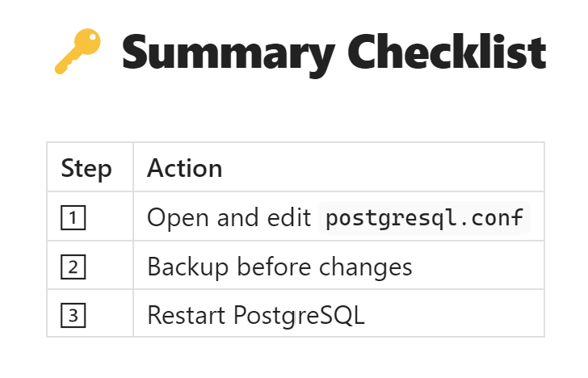

By following these steps carefully, you can modify PostgreSQL’s behavior confidently and safely without risking server downtime.

## **🔄 Dynamic Configuration Changes in PostgreSQL Using**ALTER SYSTEM

PostgreSQL offers a powerful feature that allows you to change many configuration settings ****dynamically****, without directly editing the postgresql.conf file. This is done using the SQL command ALTER SYSTEM. It simplifies configuration management, especially for DBAs who prefer making changes directly from a SQL client like psql, pgAdmin, or automation scripts.

## **🚀 Why Use**ALTER SYSTEM**?**

* ✅ You don’t need shell or file system access to the server.
* ✅ Helps automate configuration changes.
* ✅ PostgreSQL validates the setting immediately.
* ✅ Minimizes manual file editing errors.

🔒 Note: You still need sufficient PostgreSQL privileges to run ALTER SYSTEM (typically as the postgres superuser).

## **🛠 How to Use**ALTER SYSTEM

## **✅ Example: Change PostgreSQL Port**

Let’s say you want PostgreSQL to listen on port 5433 instead of the default 5432. You can execute:

ALTER SYSTEM SET port = 5433;

* This writes the new setting into PostgreSQL’s ****postgresql.auto.conf**** file (not directly into postgresql.conf).
* PostgreSQL will use this value on the next restart.

## **🔄 Apply Changes**

Many ALTER SYSTEM changes require a server restart to take effect (especially for parameters like port, shared_buffers, etc.).

You can restart PostgreSQL with:

sudo systemctl restart postgresql

Always verify that PostgreSQL restarted successfully:

sudo systemctl status postgresql

## **🔎 Verify the Change**

After restarting, you can check the current value using:

SHOW port;

This should return:

5433

## **♻️ How to Reset Settings**

If you want to undo changes made via ALTER SYSTEM, you can reset individual settings or all settings:

## **✅ Reset a Single Setting**

ALTER SYSTEM RESET port;

## **✅ Reset All Settings at Once**

ALTER SYSTEM RESET ALL;

This clears all changes from postgresql.auto.conf and reverts to the original settings defined in postgresql.conf (or compiled defaults).

## **📝 Behind the Scenes**

* ALTER SYSTEM updates a separate file called:

postgresql.auto.conf

* Usually located inside your data directory.
* This file takes precedence over postgresql.conf during startup.
* Manual edits to postgresql.auto.conf are discouraged — always use ALTER SYSTEM for safe changes.

Press enter or click to view image in full size

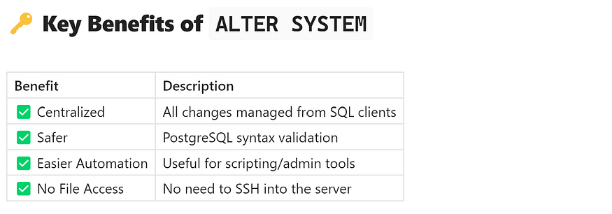

## **🚀 Final Thoughts**

ALTER SYSTEM is a DBA-friendly feature that makes PostgreSQL configuration safer and more flexible — especially in production environments where direct file access may be restricted. However, always document changes and test carefully before applying in mission-critical systems.

## **💡 Temporary Session-Level Configuration Changes in PostgreSQL**

PostgreSQL offers incredible flexibility when it comes to fine-tuning performance — and not all configuration changes require file edits or server restarts. In many cases, you may want to adjust settings ****only for the duration of your current database session****. This is where ****session-level changes**** come into play.

## **🎯 What Are Session-Level Changes?**

* 🔄 Changes apply only to your current database connection.
* 🔐 They do ****not**** affect other users or connections.
* ⏳ When you disconnect or close the session, the changes are automatically discarded.
* ✅ Great for testing or temporarily optimizing certain queries.

## **🛠 How to Apply Session-Level Changes**

PostgreSQL makes this very simple using the SET command.

## **✅ Check the Current Value**

Before making any change, it’s good practice to check the current value of the parameter you’re about to modify.

For example, to check the amount of memory allocated for sorting operations (work_mem):

SHOW work_mem;

Typical output might be:

4MB

## **✅ Apply a Temporary Change**

Let’s say you want to increase work_mem to 20MB just for the current session:

SET work_mem = '20480kB';

Or equivalently:

SET work_mem = '20MB';

🔧 PostgreSQL supports both kilobytes (kB) and megabytes (MB) units.

## **✅ Verify the New Setting**

After applying the change, you can verify that it has taken effect:

SHOW work_mem;

Output:

20MB

✅ Done! The new setting is now active ****only for your session****.

## **📝 Important Notes**

* 🔒 Other users and sessions are completely unaffected.
* 🔄 The change lasts only as long as the session is open.
* 🔄 After disconnecting, the setting automatically reverts to the system default (postgresql.conf value).

## **🔎 Use Cases for Session-Level Changes**

Scenario Why Session-Level Change Helps Query optimization Temporarily allocate more memory for a complex sort or join Testing Safely evaluate new configuration settings Development Experiment with tuning parameters without impacting others ETL/Batch Jobs Allocate more resources for large one-time jobs

## **🚫 When NOT to Use**

* ❌ Do not rely on session-level changes for permanent performance tuning.
* ❌ Do not use for changes that require consistency across multiple sessions.
* ❌ For long-term changes, modify postgresql.conf or use ALTER SYSTEM.

## **🏁 Summary**

* Session-level changes in PostgreSQL give you ****quick, isolated control**** over performance parameters.
* Use SET to modify, and SHOW to verify.
* Changes automatically disappear at session end — no risk to global settings.

This flexibility makes PostgreSQL ideal for both production DBAs and developers who need fine-grained control during query tuning or troubleshooting.

## **🚀 Conclusion**

The postgresql.conf file is your gateway to unlocking PostgreSQL's full power. Whether you're tuning for performance, enabling replication, or adjusting security settings — understanding this file gives you full control over your PostgreSQL database environment.

By learning how to locate, edit, and manage postgresql.conf, you can transform your PostgreSQL server into a finely tuned, high-performing data engine.